Malke’s Story
Gaby Weiner, granddaughter

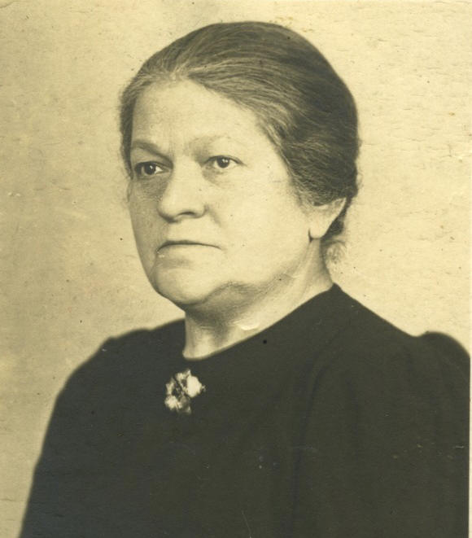
I want to show you briefly my grandmother Malke’s life as well as her death at the hands of the Nazis - so that you have a rounded picture of her not as a victim but as a person. She was also in Terezin for a short while. She was ‘ordinary’ and I think it is important that we know about people like her. I never knew Malke and have few documents or pictures of her and my mother didn’t talk about her much, perhaps because it was too painful but I have managed to find out quite a lot about her.
Malke was born 4th November 1873 in Brody in the far east of the Austro-Hungarian Empire into a deeply religious Jewish community. Brody was a shtetl town (visualise Fiddler on the Roof) and its main language was Yiddish. In 19C Brody was one of the most important trading centres of Central and Eastern Europe as it was near to the Russian border, but by Malke’s birth, decline was beginning to set in and young couples like Malke and her future husband David began to think of emigrating. They decided to move westwards to Vienna – others left for England and America.
Vienna where Malke spent most her life and where she gave birth to her children was as different to Brody as London is to an outpost of the British Empire. For Jews from Eastern Europe, Vienna signified modernity, the opportunity to live a better life with greater freedom and possibilities of work.
The couple lived in three apartments altogether in Vienna, all in the Jewish area of Leopoldstadt in Vienna District II. One apartment adjoined the shoe shop they managed and the last was in a newer building in a more prosperous part of Leopoldstadt. Malke had nine children altogether but only six survived to adulthood, two babies dying during the First World War when the family was starving. The family gradually grew a little more prosperous and all the children had some kind of extended education beyond compulsory school
At the time of Malke’s arrival in 1900, Vienna was at the peak of its influence as capital of the Austro-Hungarian Empire. Emperor Franz Joseph had ruled for more than 50 years and had transformed Vienna from an old medieval city into a modern metropolis. He had also removed the last barriers to the full citizenship of Jews; in particular they could now own property. Jews came from all parts of the empire and helped re-build Vienna. Successive Jewish generations produced glittering figures such as the composers Gustav Mahler and Arnold Schönberg, the writers Stefan Zweig, Joseph Roth and Karl Kraus, and psychoanalysts, Sigmund Freud and Alfred Adler. At this time, the Viennese Jewish community was the third largest in Europe.
The 1920s and early 1930s were the highpoints of Malke’s life. She and her husband had successfully integrated into (Jewish) Viennese life, they had a flourishing shoe shop and their children were growing up strong, confident and educated. Disaster struck in 1928 when David suddenly died of a heart attack aged 51. But Malke took over the lease of the flat, and the shop too, and life went on. The older children by now were earning money. For instance, my mother Steffi worked for various local businesses from 1928 as a clerk and later as administrator.
1920s Family Photographs
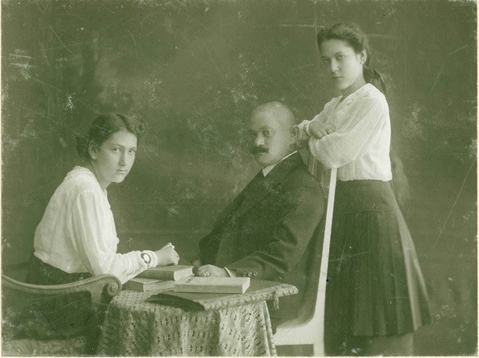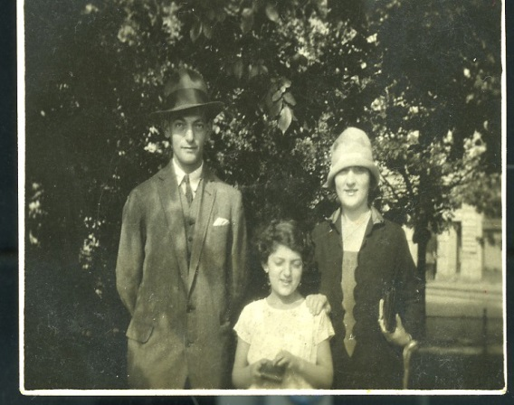

Malke had no idea about the dangers that threatened the Jews. She must have been shocked when news came of the Nazis rise to power in Germany in 1933. She was proud to be a citizen of Austria and a resident of Vienna. As anti-Semitism increased, so she also felt more proudly Jewish.
The unopposed entry into Austria of the German army in 1938, known as the Anschluss, marked the end of Jewish life as Malke knew it. Not a shot was fired. Welcomed by ‘hysterically cheering crowds’, Hitler took the decision to incorporate Austria as a whole into the Third Reich; making it just another German province. Immediately, the new regime imposed similar laws and restrictions to those already in place in Germany. Tens of thousands of people, primarily political opponents and Jews, were arrested and the first deportations to Dachau took place within a month.
There was a rush to escape, and four of the children managed to get out but none of the older generation. Steffi (my mother), and her sisters Elsa and Trude got to London and another sister Tilda and her son George, to the USA. Moritz fled to Riga in the Baltic States but eventually died in a Soviet work camp in 1945.
Malke was left in Vienna alone with her sister Frieda especially from 1940 onwards after her oldest daughter died of cancer. The shoe shop was taken in the so-called Arianization of Jewish property. From 1941Jews started to be sent to ‘transit’ camps and ghettos in the East, often to be slave labour for the Nazi war machine. In 1942 the Nazis began what was termed the ‘complete solution of the Jewish question’ or what we know as ‘the final solution’.
The bare facts concerning what happened to Malke are as follows:
Malke’s Vad Yashem Record
____________________________________________
Full Record Details for Dinger Malke,
Source: Documentation Centre for Austrian Resistance, Vienna
Last Name DINGER
First Name MALKE
Date of Birth 04/11/1873
Place of Birth BRODY
Place during the war WIEN, VIENNA, AUSTRIA
Wartime Address WIEN 2, KRUMMBAUMGASSE 2/12
Details of transport Transport IV/6 from Wien to Terezin on 9/07/1942
קישור לשילוח
Transport No.34 from WIEN, VIENNA, AUSTRIA to
THERESIENSTADT, GHETTO, CZECHOSLOVAKIA
on 26/09/1942
Prisoner Nr. in Transport 942
Place of Death TREBLINKA, Camp, POLAND
________________________________________________
Malke left Vienna for Terezin on 29th July 1942. She was asked to present herself at the local meeting point. She was allowed only a few possessions and was also required to turn in her flat key, so that non-Jews might move in. Another woman from the same building, Tini Steiner aged 80 left on the same transport; so perhaps Malke helped her older neighbour to present herself to the authorities. The distance between Vienna and Terezin is around 400 kilometres so it took about 24 hours to reach Bauschovitz station, near to the ghetto. Deportees were force-marched from the train to the ghetto; the elderly and infirm were transported in trucks, so this might have been the case for Tini and Malke. They were searched for hidden and ‘illegal’ possessions and after a time, allocated a place to stay. Malke was in Terezin for less than two months; yet she would have had time to get to know the organisation of the camp and gain a sense of what the future might hold for her.
Terezin Death Figures
________________________________________________________
- 140,000 entered Terezin between 1941 and 1945;
- 90,000 went to their deaths in Auschwitz, Treblinka and other death camps;
- 33,000 died from hunger and disease in the ghetto;
16,832 survived, mainly younger and fitter detainees, arriving late in the war.
__________________________________________________________

The first transport to Treblinka, about 50 miles northeast of Warsaw, took place on 19th September 1942, Tini was on the second 2 days later and Malke was on the fourth 5 days after that. Two thousand and four people were crushed on to that train, with the bodies of those who died en route left in the carriage, so that the number on arrival would match that on departure. Hershl Sperling aged 15, also travelling on the train, wrote of the terrible thirst in the freight car, how and where the trains were stopped, the extreme secrecy of the operation, and the heart-breaking cries for help and water to the local peasants. On arrival at Treblinka, there was enforced shearing of hair and stripping of clothes before people were harried, whipped and rushed into the gas chambers – this achieved in less than two hours.
Treblinka death figures
____________________________________________________________
- Death count estimates range from 700,000 to 900,000.
- More Jews died at Treblinka than at any other Nazi death camp excepting Auschwitz.
- 150 Jewish slave workers escaped in revolt in August 1943. Half escaped. There were no other survivors.
______________________________________________________________

The commandant of Treblinka for most of its existence, Franz Stangl, interviewed by the journalist Gitta Sereny in 1971, told of his main daily work - to ensure efficiency and the minimisation of camp corruption. What he meant was that by mid-morning the 5,000 people who had arrived earlier were dead: the ‘work’ he referred to was the disposal of the bodies, which took most of the rest of the day. Stangl avoided referring to the dead as people.
For Malke, one of Stangl’s non-people, Treblinka marked the end of her life and her suffering. She may have died on the journey to the camp or she may have survived to die in the gas chambers. She was 69. Her body was collected by young Jewish prisoners like Hershl Spurling and then quickly burnt. She has no grave and on leaving, the Nazis scorched the whole place to the ground.
It was not until 1947 that anyone knew about Malke’s death. Following a request for information, Malke’s daughters received a short note from the Red Cross, nearly five years afterwards.

Red Cross response to Enquiry about Malke
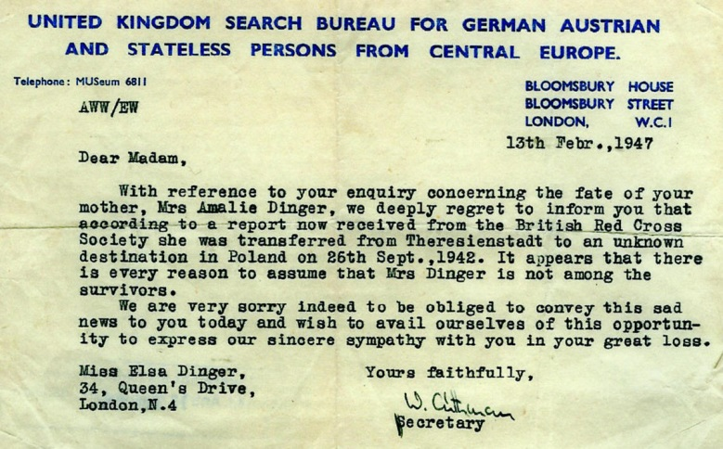
And that is all there is to say.

Rathkolb, p11

